PHASE-WISE PROJECT DOCUMENTATION

AI WeatherWise
Deliver Intelligent Weather Forecasts and Insights

Document type | Project type | Core stack
Academic / project submission document | AI-powered RESTful backend / headless weather service | Node.js • Express.js • MongoDB • Mongoose • JWT • Gemini AI • Weather API

Template availability note: The supplied attachment contained the project brief but not a separate reference document. This document therefore follows the prescribed eight-phase order, headings, tables, documentation flow, and evidence-placeholder rules from the brief.

Prepared for | Team leader | Team members
[INSERT INSTITUTION / COURSE] | [YOUR NAME] | [MEMBER 2 NAME]; [MEMBER 3 NAME]; [MEMBER 4 NAME]; [MEMBER 5 NAME]

Submission date: [INSERT SUBMISSION DATE]

Document Contents
This document preserves the requested eight-phase project-documentation structure. Page numbers may update when the file is opened in Microsoft Word and fields are refreshed.
Phase 1 — Brainstorming & Ideation
Phase 2 — Requirement Analysis
Phase 3 — Project Design
Phase 4 — Project Planning
Phase 5 — Project Development
Phase 6 — Project Testing
Phase 7 — Project Documentation
Phase 8 — Project Demonstration
Project Benefits, Limitations and Future Enhancements
GitHub, Demo Video and Evidence Register
Final Quality and Consistency Checklist

PHASE 1 — BRAINSTORMING & IDEATION
AI WeatherWise is conceived as a centralized backend service that turns raw weather data into understandable, actionable information. The project deliberately focuses on REST APIs rather than a traditional HTML frontend.

1.1 Project Idea
The system allows a user to register, authenticate with JWT, save favorite locations, retrieve current weather information, and request an AI-generated summary with activity and clothing recommendations. A client such as Postman, Thunder Client, a mobile application, or a future web frontend can consume the API.

1.2 Problem Identification
Weather services commonly expose many measurements—temperature, humidity, wind, visibility, pressure, and precipitation. Users must often interpret these values manually and repeat the same process for several cities. The result is fragmented information and limited guidance for practical decisions.

1.3 Existing Problem
- Raw weather values are not always expressed in simple, user-oriented language.
- Users may need to compare multiple cities or repeatedly search for the same places.
- Favorite locations and personalized access are not always available in a single service.
- External weather and AI services can fail independently, requiring graceful fallback behavior.

1.4 Proposed Solution
AI WeatherWise combines secure user management, favorite-location persistence, a configured weather provider, and Google Gemini AI in one structured RESTful backend. The backend validates requests, retrieves weather data, optionally asks Gemini to interpret it, and returns a predictable JSON response. If the AI service is unavailable, the service can return a clearly identified rule-based or data-based fallback response rather than failing silently.

1.5 Objectives
- Build a modular Node.js and Express.js REST API.
- Implement secure registration, login, password hashing, and JWT-protected routes.
- Persist users and favorite locations with MongoDB and Mongoose.
- Integrate a configured weather API for current weather information.
- Generate natural-language summaries and recommendations with Gemini AI.
- Provide validation, centralized errors, security controls, and fallback behavior.
- Produce maintainable project documentation and an API demonstration plan.

1.6 Target Users
User group | Need addressed | Example use
Individual users | Quickly understand local or travel weather | Check whether outdoor plans are suitable
Travelers / commuters | Compare several saved locations | Monitor a departure city and destination
Developers | Consume weather intelligence through an API | Integrate the service into a future app
Academic evaluators | Review an end-to-end backend project | Inspect architecture, security, AI and testing

1.7 Key Features
- User registration and login
- JWT authentication and protected routes
- Favorite location creation, retrieval, management and deletion
- Current weather retrieval
- AI weather summary and recommendations
- Fallback mode for AI service failure
- Input validation and centralized error handling
- Health-check endpoint and API-client demonstration

1.8 Innovation and AI Component
The differentiator is the interpretation layer. Instead of exposing only numeric readings, the backend supplies relevant weather context to Gemini AI and requests concise, useful language such as a summary, activity guidance, clothing suggestions, and cautions. The output remains advisory; the service should not present AI text as a guaranteed prediction or safety certification.

1.9 Main Use Case / Scenario
Alex wants to monitor weather in several cities. Alex registers and logs in, saves a favorite city, requests current weather, and then requests an AI insight. The response explains the conditions in natural language and provides recommendations. Alex can repeat the process for other saved locations or remove locations that are no longer useful.

1.10 Expected Outcome
The expected outcome is an editable, testable backend project that exposes coherent API behavior, protects credentials, separates responsibilities into modules, and makes weather data easier to understand. Actual execution results, screenshots, performance figures and repository links remain evidence items to be inserted only when available.

PHASE 2 — REQUIREMENT ANALYSIS

2.1 Functional Requirements
ID | Requirement | Description
FR-01 | User registration | Accept valid name, email and password; hash the password before persistence.
FR-02 | User login | Verify credentials and issue a JWT on successful authentication.
FR-03 | Protected access | Reject requests without a valid token on protected routes.
FR-04 | Favorite locations | Create, list, manage if implemented, and delete locations owned by the authenticated user.
FR-05 | Weather retrieval | Request current weather for a valid city or configured location.
FR-06 | AI insight | Generate a summary and recommendations from weather data when Gemini is available.
FR-07 | Fallback | Return a transparent fallback insight when AI generation fails or is unavailable.
FR-08 | Health check | Report basic service availability without exposing secrets.

2.2 Non-Functional Requirements
Quality | Requirement
Security | Passwords are hashed; secrets are environment-based; protected endpoints verify JWTs.
Reliability | External-service failures produce controlled errors or fallback responses.
Maintainability | Routes, controllers, services, models and middleware have clear responsibilities.
Usability | JSON responses use consistent status codes and understandable messages.
Scalability | Stateless API behavior and modular services support future clients and deployment.
Testability | Endpoints can be exercised independently through Postman or Thunder Client.
Performance | Avoid unnecessary external calls and return only relevant response data.

2.3 Software and Hardware Requirements
Category | Minimum / expected requirement
Operating system | Windows, macOS or Linux
Runtime | Node.js v16+ and npm
Database | MongoDB local instance or managed MongoDB deployment
AI service | Google Gemini API access and Google GenAI SDK
Weather service | OpenWeatherMap or the configured weather API
Development IDE | Visual Studio Code or equivalent
Testing | Postman or Thunder Client
Hardware | A modern dual-core computer, 4 GB RAM minimum, stable internet connection, and sufficient storage for Node.js dependencies and logs

2.4 User and System Requirements
- Users need an email and password to authenticate.
- Authenticated users need a valid JWT to access personal locations and protected weather/AI operations where configured.
- The server needs access to MongoDB and valid external API credentials.
- The application must not depend on a frontend; an API client is sufficient for operation.
- The service should return useful error messages without revealing stack traces or secrets.

2.5 API, Database, Security and AI Requirements
Area | Requirements
API | REST conventions, JSON input/output, validation, appropriate HTTP status codes, health check.
Database | User and Location collections; one user can own many locations; timestamps for locations.
Security | JWT, bcrypt/bcryptjs, CORS policy, input sanitization, environment variables, centralized errors.
AI | Send relevant normalized weather data to Gemini; request concise advisory language; handle timeout/failure and do not expose keys.
External APIs | Weather provider and Gemini credentials must be configured outside source control; rate limits and connectivity must be considered.

2.6 Development and Testing Tools
- Visual Studio Code, npm, Nodemon, Git and GitHub
- Postman and/or Thunder Client
- MongoDB Compass or another MongoDB inspection tool, if used
- Configured Node.js logging and API-client response inspection

PHASE 3 — PROJECT DESIGN

3.1 System Architecture
The proposed architecture follows the brief: Client or API testing tool → Express.js API gateway → authentication and middleware → controllers → services → weather API and Gemini AI → MongoDB/Mongoose. The service is headless; the client is external to the backend.
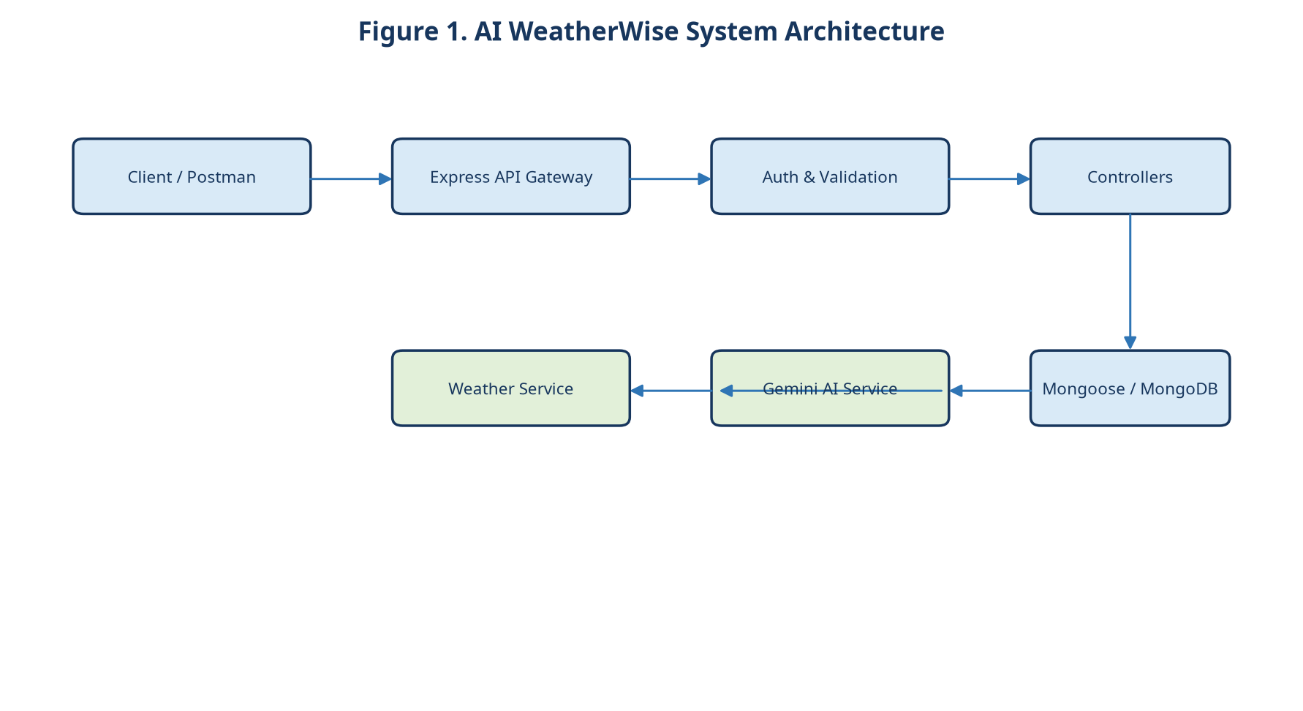
System architecture for the AI WeatherWise REST backend.

3.2 High-Level Component Design
Component | Responsibility
Routes | Map HTTP methods and paths to controllers.
Middleware | Authenticate JWTs, validate input, configure CORS, and handle errors.
Controllers | Coordinate request processing and construct HTTP responses.
Services | Encapsulate weather-provider and Gemini integrations, normalization, prompts and fallback logic.
Models | Define Mongoose schemas and database access for User and Location.
Configuration / utilities | Read environment variables, provide shared helpers and safe error/logging behavior.

3.3 MVC Architecture for a Headless API
In this project, the Model layer consists of Mongoose schemas and database operations. The Controller layer receives requests, invokes services and formats responses. The View is not an HTML page: the routing and JSON response layer acts as the interface consumed by API clients. This is an API-oriented interpretation of MVC and should not be described as a traditional browser frontend.
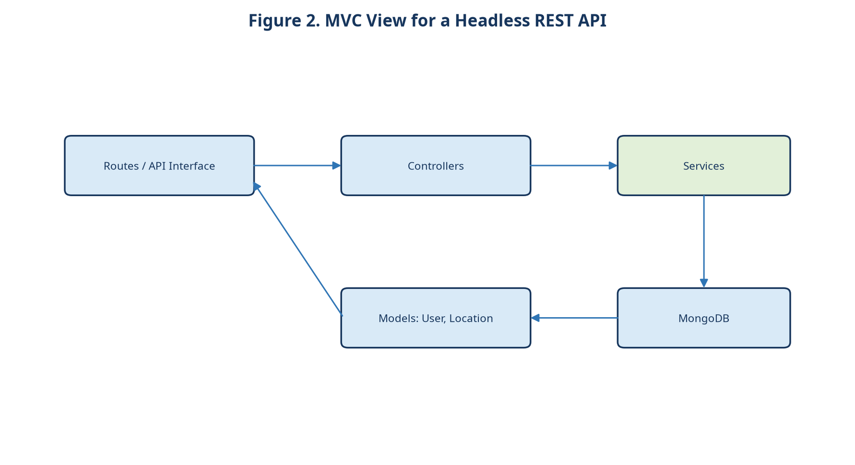
MVC responsibility mapping for a headless REST API.

3.4 Database Design
Entity | Fields | Purpose
USER | _id, name, email, password, role | Stores identity and authorization-related user data. Password is stored only as a secure hash.
LOCATION | _id, user, city, country, createdAt | Stores a user-owned favorite location. The user field references the owning User.

Relationship: one User can have many Locations. Each Location belongs to exactly one User through its user reference. Queries for a user’s favorites must filter by the authenticated user identifier so that one user cannot access another user’s saved locations.
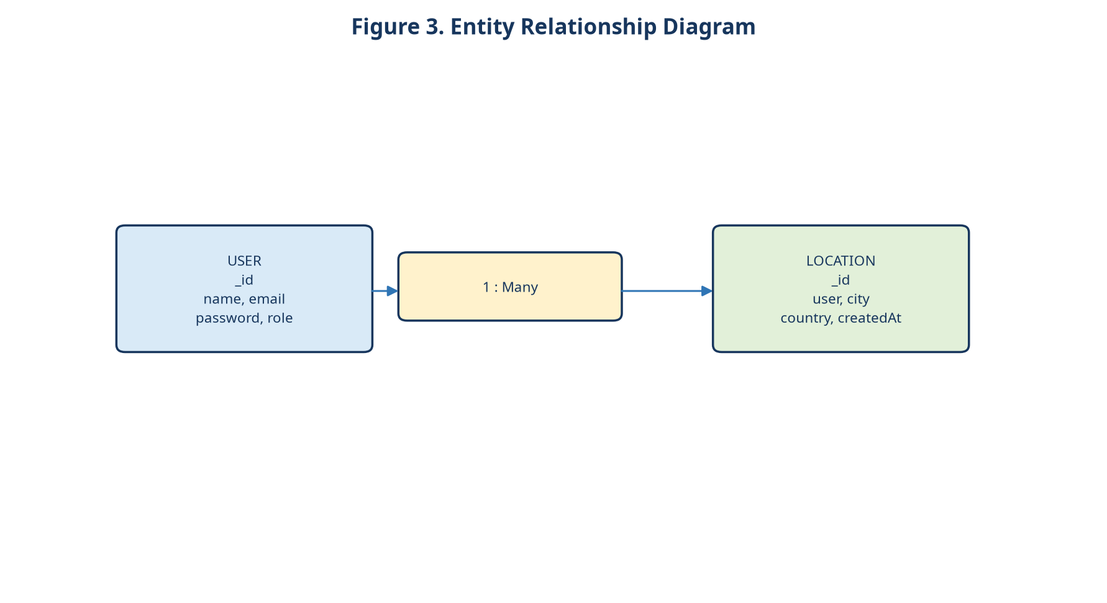
User-to-location relationship: one User to many Location records.

3.5 Data and User Flows
- Client registers or logs in and receives a JWT.
- Client sends the JWT to a protected endpoint.
- Middleware verifies the token and attaches the authenticated user identity to the request.
- The controller validates input and calls the appropriate service.
- The weather service calls the configured weather provider and normalizes the response.
- The AI service optionally sends relevant weather data to Gemini.
- The controller returns a structured JSON response; if AI fails, the fallback path is used.
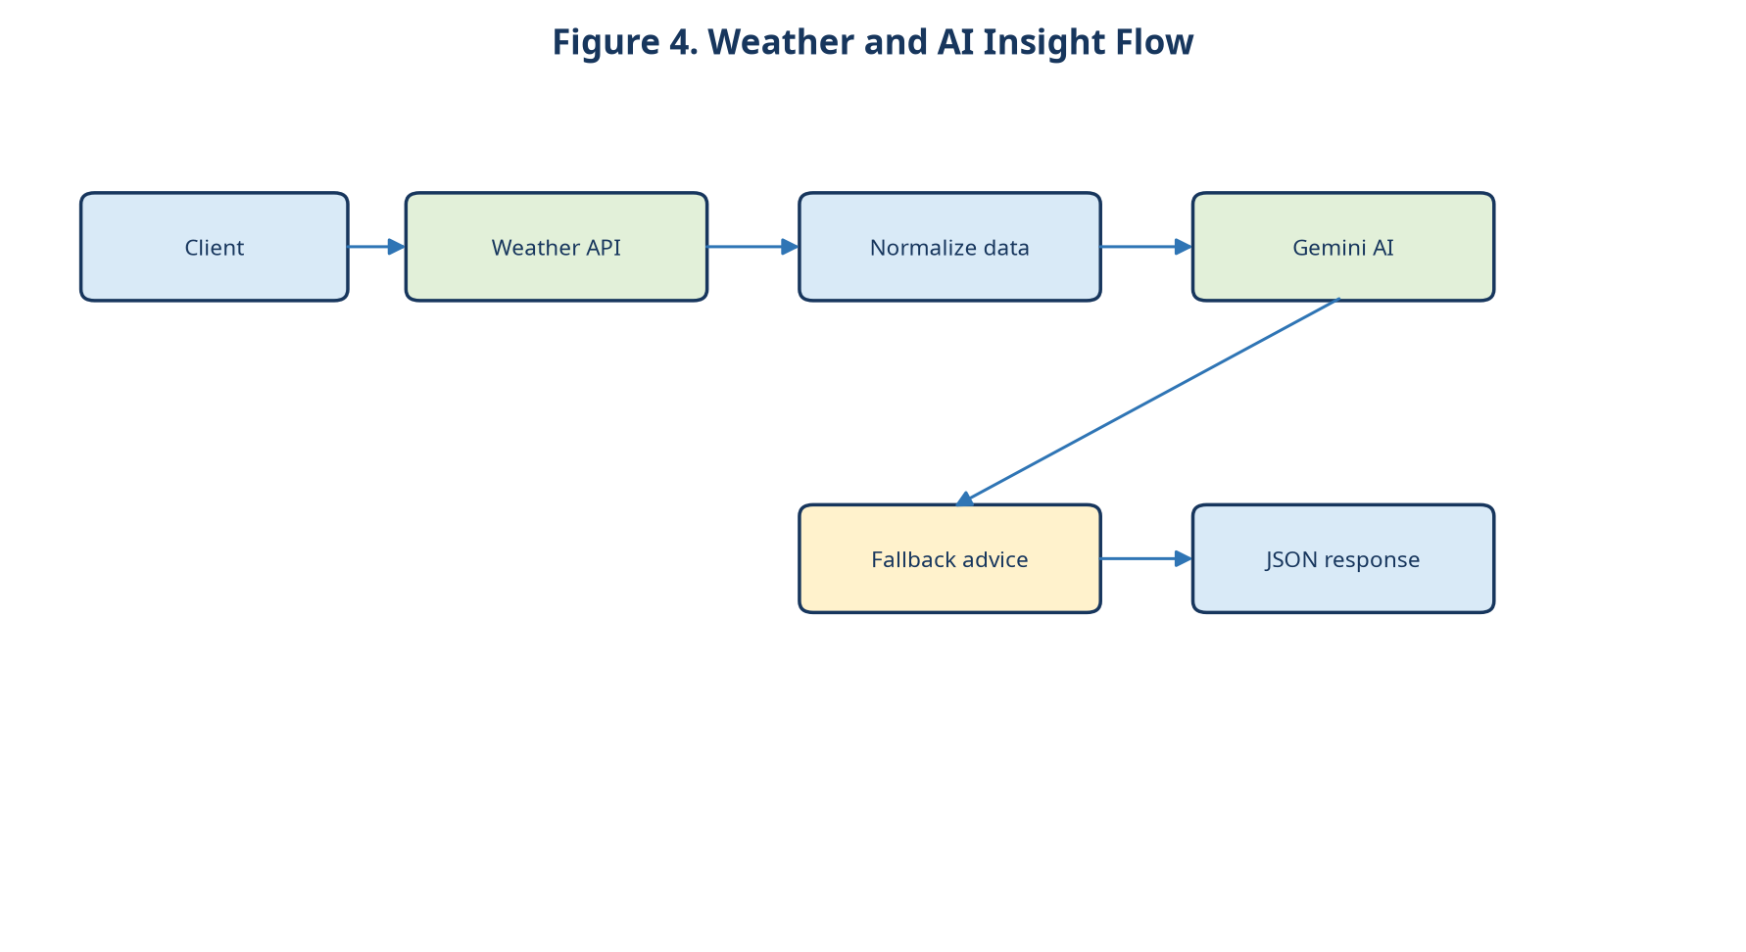
Weather retrieval and AI insight flow, including fallback behavior.

3.6 Authentication Flow
- Registration validates fields, checks email uniqueness where implemented, hashes the password, and creates the user.
- Login compares the supplied password with the stored bcrypt/bcryptjs hash.
- A signed JWT is returned after successful login.
- Protected middleware reads the bearer token, verifies the signature and expiry, and rejects invalid credentials.
- Controllers use the authenticated user identifier when accessing personal locations.

3.7 API Endpoint Design
Method | Endpoint | Purpose | Auth
POST | /api/auth/register | Register a user | No
POST | /api/auth/login | Authenticate and issue JWT | No
POST | /api/locations | Add favorite location | Yes
GET | /api/locations | List authenticated user’s favorites | Yes
PUT/PATCH | /api/locations/:id | Manage a favorite if implemented | Yes
DELETE | /api/locations/:id | Delete an owned favorite | Yes
GET | /api/weather?city=... | Fetch current weather | As configured
POST | /api/ai/insight | Generate weather summary/recommendations | As configured
GET | /api/health | Check service availability | No

Implementation note: The endpoint paths above are a documented design baseline because the actual source repository and exact route names were not supplied. Replace any path that differs from the implemented code before submission.

3.8 Security Architecture
- JWT bearer authentication for protected routes.
- bcrypt/bcryptjs hashing with no plaintext password persistence.
- Environment variables for MongoDB, JWT, Gemini and weather-provider credentials.
- CORS configured for intended clients rather than blindly allowing all origins in production.
- Validation and sanitization at API boundaries.
- Centralized error handling that avoids leaking internal stack traces.
- Ownership checks for Location records.
- Optional role checks only where roles are genuinely implemented.

PHASE 4 — PROJECT PLANNING

4.1 Project Scope
In scope: REST API design, authentication, location management, weather integration, Gemini insight generation, fallback behavior, MongoDB persistence, API testing, documentation and demonstration. Out of scope for the current backend: a production web/mobile frontend, push-notification infrastructure, guaranteed severe-weather warnings, and any feature not supported by the configured services.

4.2 Work Breakdown and Responsibilities
Role | Primary responsibilities
Team Leader — [YOUR NAME] | Coordination, architecture, backend integration, GitHub coordination, final integration and documentation coordination.
Member 2 — [MEMBER 2 NAME] | Authentication, JWT, password hashing and security middleware.
Member 3 — [MEMBER 3 NAME] | Weather API integration, weather service and weather endpoint.
Member 4 — [MEMBER 4 NAME] | Gemini AI integration, summaries and recommendations.
Member 5 — [MEMBER 5 NAME] | MongoDB/Mongoose, favorite locations, API testing and documentation/testing support.

4.3 Timeline and Milestones
Milestone | Planned activities | Evidence to attach
M1: Ideation | Problem, objectives, use cases and scope | Approved idea/problem statement
M2: Requirements | Functional, non-functional, security and external-service requirements | Requirements review notes
M3: Design | Architecture, ER model, flow diagrams and endpoint baseline | Architecture/ER diagrams
M4: Foundation | Node.js setup, Express server, configuration and database connection | Source code / setup screenshot
M5: Core modules | Auth, JWT, location management and validation | API requests and code evidence
M6: Integrations | Weather provider, Gemini service and fallback behavior | API responses / logs
M7: Testing | Positive, negative, validation and failure-path tests | Postman collection/results
M8: Submission | Documentation, demo, GitHub hygiene and final review | Final repository and demonstration

4.4 Dependencies and Risk Mitigation
Risk / dependency | Impact | Mitigation
Weather API outage or rate limit | Weather endpoint cannot retrieve current data | Timeouts, clear errors, provider configuration and test doubles where appropriate.
Gemini unavailable or rate-limited | AI insight cannot be generated | Fallback response, explicit status and no silent fabrication.
Credential leakage | Security and account compromise | Use .env locally, .gitignore, secret rotation and placeholders in documentation.
Schema or ownership bug | Users may see incorrect locations | Validate IDs, filter by authenticated user and test unauthorized access.
Unclear exact implementation routes | Documentation may diverge from code | Compare the final source before submission; mark baseline routes as implementation-dependent.
Team integration conflicts | Delayed delivery | Branch conventions, pull requests, reviews and a shared checklist.

4.5 Testing and Documentation Plan
- Create a Postman/Thunder Client collection organized by authentication, locations, weather, AI and system tests.
- Record request, expected status, response shape and evidence location for every test.
- Document configuration without including real secrets.
- Update README, endpoint documentation and diagrams after implementation changes.
- Run the final consistency checklist before submission.

4.6 GitHub and Demonstration Plan
Use a public repository only if the team intends the source to be public. Keep secrets out of Git history, include a meaningful README and .gitignore, use branches or pull requests for team work, and attach only genuine screenshots/results. The demonstration should use Postman or Thunder Client to show the backend workflow.

PHASE 5 — PROJECT DEVELOPMENT

5.1 Initialization and Dependencies
Initialize the Node.js project with npm, install Express, Mongoose, JSON Web Token support, bcrypt/bcryptjs, CORS, validation utilities and the SDK/client required by the configured weather and Gemini providers. Use Nodemon for local development where appropriate. The exact package list must match the implemented package.json.

5.2 Suggested Project Structure
Path | Purpose
controllers/ | Request orchestration and response handling
models/ | Mongoose User and Location schemas
routes/ | Authentication, locations, weather, AI and system routes
services/ | Weather provider, Gemini integration and fallback logic
middleware/ | JWT authentication, validation, errors and security
utils/ | Shared helpers and response/error utilities
config/ | Database and application configuration
.env | Local secrets and configuration; never commit
.gitignore | Exclude node_modules, .env, logs and generated secrets
package.json | Dependencies and scripts
index.js | Application entry point; actual filename may differ
README.md | Installation, configuration, API use and testing notes

5.3 Environment Configuration
Variable | Purpose | Example placeholder
PORT | HTTP server port | 5000
MONGO_URI | MongoDB connection string | YOUR_MONGODB_URI
JWT_SECRET | JWT signing secret | YOUR_JWT_SECRET
GEMINI_API_KEY | Gemini credential | YOUR_GEMINI_API_KEY
OPENWEATHER_API_KEY | Weather-provider credential | YOUR_OPENWEATHER_API_KEY

Security rule: Actual secret values must never be committed to GitHub, placed in screenshots, or inserted into this document. Use a local .env file and a safe example configuration file such as .env.example.

5.4 Server and Database Setup
- Load environment variables before creating external clients.
- Create the Express application and register JSON parsing, CORS and request validation.
- Connect to MongoDB through Mongoose and handle connection errors.
- Register routes and a centralized not-found/error handler.
- Start the server on the configured port and expose a non-sensitive health endpoint.

5.5 Models and Authentication Implementation
The User model should define required identity fields and protect the password through hashing. The Location model should reference User and include city, country and createdAt. Registration and login controllers should validate inputs, handle duplicate or invalid credentials safely, and return a token only after successful authentication. JWT middleware should attach a trusted user identifier to the request after verification.

5.6 Location, Weather and AI Modules
Location controllers should enforce ownership on every read, update and delete operation. The weather service should call the configured provider and normalize the fields required by the API. The Gemini service should receive only the relevant weather context and a controlled prompt. A fallback function should produce a conservative, clearly labeled response using available weather data when Gemini is unavailable.

5.7 Validation, Errors and Security
- Validate required fields, email format, password constraints and location identifiers.
- Sanitize user-controlled strings before using them in queries or external prompts.
- Use status codes consistently: 2xx success, 4xx client/authentication errors, 5xx controlled service errors.
- Avoid returning provider credentials, raw stack traces or sensitive database details.
- Log enough operational detail for debugging without logging secrets or passwords.

5.8 Server Execution
A typical local workflow is: install dependencies, configure .env, start MongoDB, run the development script with Nodemon, and exercise the health endpoint. Exact commands must be copied from the final package.json and README rather than assumed.

PHASE 6 — PROJECT TESTING
Postman or Thunder Client is the primary testing tool. The tables below define the test plan. They are not claims that tests have already passed; actual evidence must be inserted from the implemented project.

6.1 Test Case Matrix
ID | Test | Input / condition | Expected behavior | Evidence status
TC-01 | User Registration | Valid name, email and password | 201/200 with user/token shape as implemented | [INSERT ACTUAL RESULT]
TC-02 | User Login | Registered credentials | 200 with JWT | [INSERT ACTUAL RESULT]
TC-03 | JWT Authentication | Protected request with valid bearer token | Request authorized | [INSERT ACTUAL RESULT]
TC-04 | Add Favorite Location | Authenticated request with city/country | Location created | [INSERT ACTUAL RESULT]
TC-05 | Get Favorite Locations | Authenticated GET | Only owner’s locations returned | [INSERT ACTUAL RESULT]
TC-06 | Delete Favorite Location | Authenticated owner deletes ID | Location deleted | [INSERT ACTUAL RESULT]
TC-07 | Weather API | Valid city/location | Weather JSON returned | [INSERT ACTUAL RESULT]
TC-08 | Gemini AI Insight | Valid weather context | Summary/recommendation returned | [INSERT ACTUAL RESULT]
TC-09 | Invalid Authentication | Missing/invalid JWT | 401/403 as implemented | [INSERT ACTUAL RESULT]
TC-10 | Invalid Input | Malformed email or invalid field | 4xx validation error | [INSERT ACTUAL RESULT]
TC-11 | Missing Fields | Omit required body field | 4xx validation error | [INSERT ACTUAL RESULT]
TC-12 | Invalid Location | Unknown or malformed location | Controlled 4xx/provider error | [INSERT ACTUAL RESULT]
TC-13 | External API Failure | Simulate provider failure/timeout | Controlled error response | [INSERT ACTUAL RESULT]
TC-14 | AI Failure / Fallback | Simulate Gemini failure | Fallback insight and status | [INSERT ACTUAL RESULT]
TC-15 | Health Check | GET health endpoint | Healthy status without secrets | [INSERT ACTUAL RESULT]

6.2 Negative and Security Testing
- Attempt to access another user’s Location identifier.
- Try expired, malformed and tampered JWTs.
- Submit overly long or unexpected strings.
- Verify duplicate registration behavior.
- Confirm passwords and API keys never appear in responses or logs.
- Verify CORS behavior against the intended client origins.

6.3 Evidence Placeholders
- [INSERT POSTMAN REGISTER API SCREENSHOT HERE]
- [INSERT LOGIN API SCREENSHOT HERE]
- [INSERT WEATHER API SCREENSHOT HERE]
- [INSERT AI INSIGHT API SCREENSHOT HERE]
- [INSERT ACTUAL TEST RESULT HERE]
- [INSERT ACTUAL RESPONSE SCREENSHOT HERE]
Evidence rule: Do not mark a test as passed until the actual response, screenshot, log or other verifiable evidence has been attached and reviewed.

PHASE 7 — PROJECT DOCUMENTATION

7.1 Project Overview
AI WeatherWise is a modular REST backend for weather retrieval and intelligent weather interpretation. Its core entities are User and Location. It is intended to be consumed by API clients and future applications rather than presenting a built-in user interface.

7.2 Installation and Configuration
- Install Node.js v16+ and npm.
- Clone or obtain the project source from the actual repository.
- Run the package manager install command defined by package.json.
- Create .env from the documented example and supply valid local credentials.
- Start MongoDB or configure a managed MongoDB connection.
- Run the development or production start command from the README.
- Use the health endpoint to confirm local availability.

7.3 Database Setup
Create or select a MongoDB database through MONGO_URI. Mongoose should create or use the User and Location collections according to the schemas. The password field must contain only a secure hash. Location queries must be scoped to the authenticated user.

7.4 API Documentation
Endpoint group | Typical operations | Notes
Authentication | Register and login | Returns authentication result according to implementation.
Locations | Create, list, update/manage if implemented, delete | Protected and owner-scoped.
Weather | Fetch current weather | Depends on configured provider and valid location input.
AI | Generate insight/recommendations | Depends on weather data and Gemini availability.
System | Health check | Must not expose secrets.

7.5 Running and Testing
Use Postman or Thunder Client to send requests in dependency order: health check, registration, login, protected location operations, weather retrieval and AI insight. Save the collection and sanitized evidence only after verifying that no secrets or personal data are exposed.

7.6 Error Handling and Fallback Mode
The API should distinguish validation failures, authentication failures, missing resources, provider failures and internal errors. When Gemini cannot produce an insight, the API should identify the fallback condition and provide conservative advice derived from available weather fields, or return a controlled service-unavailable response if fallback is not implemented. Documentation must match the actual behavior.

7.7 Security and GitHub Instructions
- Commit source code, package metadata, README and sanitized examples.
- Do not commit .env, keys, tokens, database credentials or private screenshots.
- Use .gitignore and review Git history before publishing.
- Document setup and route behavior without inventing repository URLs.
- Use [INSERT GITHUB REPOSITORY LINK] until the real URL is available.

7.8 Limitations
- Dependency on external weather API availability and rate limits.
- Dependency on Gemini availability, quotas and response quality.
- Internet connectivity is required for external integrations.
- AI-generated recommendations may require human judgment and validation.
- The current deliverable describes a headless backend rather than a complete end-user frontend.
- Exact endpoint names and implementation details must be reconciled with the final source code.

7.9 Future Enhancements
- Web or mobile client
- Weather alerts and push notifications
- Multi-day forecasts and severe-weather warnings
- Automatic location detection
- More personalized recommendations and analytics
- Voice-based weather queries
- Multilingual AI weather insights

7.10 Conclusion
AI WeatherWise provides a practical foundation for an intelligent weather service by combining secure access, persistent favorite locations, current weather data and natural-language AI interpretation. Its modular architecture supports future clients and enhancements while keeping the present scope honest and testable.

7.11 References
- Node.js documentation — https://nodejs.org/
- Express.js documentation — https://expressjs.com/
- MongoDB documentation — https://www.mongodb.com/docs/
- Mongoose documentation — https://mongoosejs.com/docs/
- JSON Web Tokens — https://jwt.io/
- Google Gemini API documentation — https://ai.google.dev/
- OpenWeather documentation — https://openweathermap.org/api
- Postman learning center — https://learning.postman.com/

PHASE 8 — PROJECT DEMONSTRATION
The demonstration is API/backend based. Use Postman, Thunder Client or another API client; do not claim a frontend screen that has not been implemented.

8.1 Demonstration Sequence
- Introduce the project name and purpose.
- Explain the problem of interpreting raw weather data and managing multiple locations.
- Present the proposed RESTful solution.
- Show the technology stack and architecture diagram.
- Register a test user using sanitized data.
- Log in and display the returned JWT without exposing it publicly.
- Use the JWT to access a protected endpoint.
- Add and list a favorite location.
- Fetch current weather for a valid location.
- Request an AI weather insight and recommendation.
- Demonstrate invalid authentication or input handling.
- Demonstrate AI failure/fallback only if the behavior is implemented and can be shown safely.
- Summarize benefits, limitations and future enhancements.
- Conclude with the repository, README and evidence register.

8.2 Demonstration Script Table
Step | What to show | Evidence
1 | Project introduction and problem | [INSERT INTRODUCTION SLIDE/SCREENSHOT]
2 | Architecture and data flow | [INSERT PROJECT ARCHITECTURE DIAGRAM HERE]
3 | Registration and login | [INSERT POSTMAN REGISTER API SCREENSHOT HERE]
4 | JWT-protected request | [INSERT LOGIN API SCREENSHOT HERE]
5 | Favorite location workflow | [INSERT LOCATION RESPONSE SCREENSHOT HERE]
6 | Weather retrieval | [INSERT WEATHER API SCREENSHOT HERE]
7 | AI insight and recommendations | [INSERT AI INSIGHT API SCREENSHOT HERE]
8 | Error/fallback behavior | [INSERT ACTUAL FALLBACK EVIDENCE HERE]
9 | Final output and benefits | [INSERT FINAL OUTPUT SCREENSHOT HERE]

8.3 Demo Video
The final demonstration video should cover the project name, purpose, problem, solution, technologies, working flow, API demonstration, AI output, final result and benefits. Use [INSERT DEMO VIDEO LINK] until a real link is available. Do not create or imply a fake Google Drive link.

PROJECT BENEFITS
- Centralized weather service accessible through APIs
- Secure authentication and protected user data
- Favorite location management
- Real-time weather information through an external provider
- Natural-language summaries generated with AI
- Activity and clothing recommendations
- Easier interpretation of raw weather metrics
- Reusable API integration for future clients
- Fallback handling for AI-service failure
- Modular and scalable backend architecture

SCREENSHOTS, DIAGRAMS AND EVIDENCE REGISTER
Evidence item | Status / action
System architecture diagram | Included in this document; verify against final implementation.
MVC diagram | Included in this document; verify against final module structure.
ER diagram | Included in this document; based on User and Location entities.
User-flow / weather-flow diagram | Included in this document; verify against actual service behavior.
Postman registration, login, weather and AI screenshots | [INSERT ACTUAL SCREENSHOTS]
Database screenshot | [INSERT DATABASE SCREENSHOT HERE]
GitHub repository | [INSERT GITHUB REPOSITORY LINK]
Demo video | [INSERT DEMO VIDEO LINK]
Team names and submission date | Replace bracketed fields before submission.

FINAL QUALITY AND CONSISTENCY CHECKLIST
- ☐ Project name is consistently AI WeatherWise.
- ☐ Project type is consistently RESTful backend / headless API.
- ☐ Only User and Location are treated as core database entities.
- ☐ No blog, post, category, comment or unrelated template terminology remains.
- ☐ All eight phases are present and in order.
- ☐ Technology stack matches the specified Node.js, Express.js, MongoDB, Mongoose, JWT, bcrypt/bcryptjs, Gemini and weather API stack.
- ☐ Exact endpoint names are reconciled with the final source code.
- ☐ No real API keys, passwords or secrets appear in the document.
- ☐ No screenshots, URLs, test results, dates, names or performance numbers are fabricated.
- ☐ Evidence placeholders are replaced only with genuine evidence before submission.
- ☐ Architecture, MVC, ER, user flow and AI flow diagrams match the implemented system.
- ☐ README and GitHub instructions match the final repository.
- ☐ The final DOCX opens correctly and remains editable.
Submission reminder: Replace all bracketed evidence and identity placeholders, reconcile the endpoint baseline with the actual code, refresh the table of contents if added in Word, and review the document before submitting.

